Developing practical ways of integrating pluralistic approaches* in the language classroom

  - How can we help our learners to make links between the various languages in their repertoires?
  - How can we help our learners to capitalize on their knowledge and experiences when learning a new language?
  - How can we help our learners to develop positive attitudes towards linguistic and cultural diversity?
  - What knowledge, attitudes and skills do we help our learners to develop when we work with more than one language variety in the language classroom?
-
Exemplar classroom resource 1:

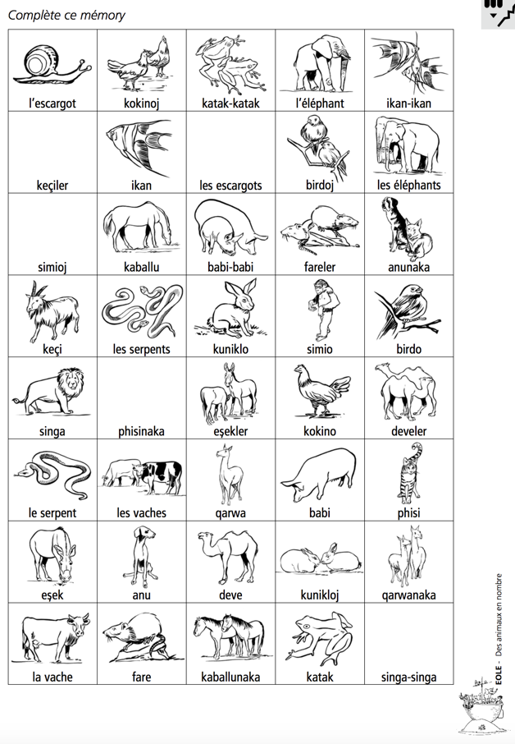
Source : Perregaux, C., De Goumoëns, C., Jeannot, D., & De Pietro, J. F. (2003). Education au langage et Ouverture aux langues à l'école (EOLE). Neuchâtel, Suisse: Secrétariat général de la CIIP.
http://eole.irdp.ch/activites_eole/animaux.pdf (in French)

Activity:

- Draw (or write down the names of) the missing animals.
- Identify the number of languages and work out the rules for singular and plural in these languages.
- With your partner(s), discuss how you found them and how you worked out the rules.

For more activities and for the names of the languages used, see the pdf above (in French)

Possible objectives for learners:
Reflect on number through the observation of the way singular/plural is expressed in various languages.
(For French-speaking learners or learners of French, become aware of a difficult point in French: the plural ending is not audible)
Acquire knowledge about languages (for example, that each language has its own system**).
Develop observation / comparison / analysis skills.
Develop curiosity about discovering how languages work.**
Develop confidence in one’s capacities of observation / of analysis of little known or unknown language. **
Develop respect for all languages and varieties.

Reflective questions:
How do these resources address the initial questions?
How do learners benefit from them?
What other objectives could you achieve with these activities?
How would you use these resources and adapt them for your own context?

Food for thought:
- *See the definition of pluralistic approaches on the FREPA website. FREPA = Framework of Reference for Pluralistic approaches to Languages and Cultures
- **These objectives correspond to FREPA descriptors, which can be found on the FREPA website: Descriptors for Knowledge, for Attitudes, for Skills
- See an issue of the Swiss pluringual journal of language teaching and learning dedicated to pluralistic approaches Babylonia: https://babylonia.online/index.php/babylonia/issue/view/136

Other resources:
More activities for all pluralistic approaches (awakening to languages, intercultural approach, intercomprehension between related languages, integrated learning approach) can be found on the FREPA website, under Teaching and learning materials

